**PROJECT**

**LINUX FUNDAMENTALS**

**Objective**

Create automation to display the Linux operating system

information.

**1. Display the Linux version.**

below command was and the following text manipulation

hostnamectl | grep Kernel | cut -d ":" -f 2 | awk '{print $2}'

Below is the break down of the build-up to getting the linux version.

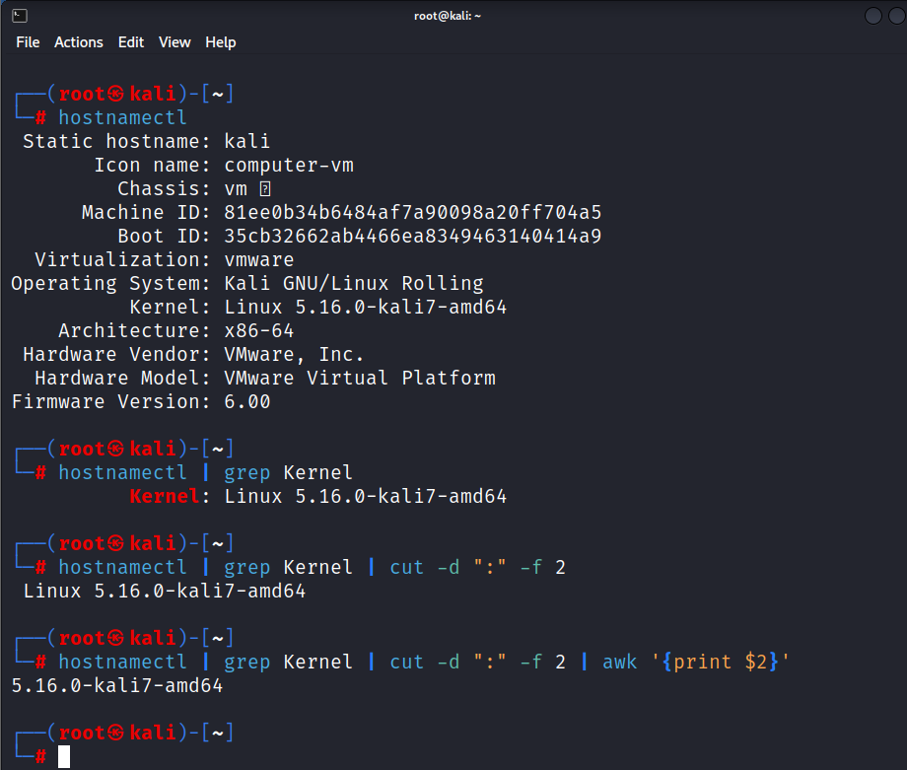

**2. Display the private IP address, public IP address, and the default**

**gateway.**

Command used:

"Private IP: $(ifconfig |head -n 2 | grep "inet" | awk '{print $(2)}')"

"Public IP: $(curl -s ifconfig.co)"

"Default gateway: $(ip r | grep "via" | awk '{print $(3)}')"

1. (ifconfig |head -n 2 | grep "inet" | awk '{print $(2)}’

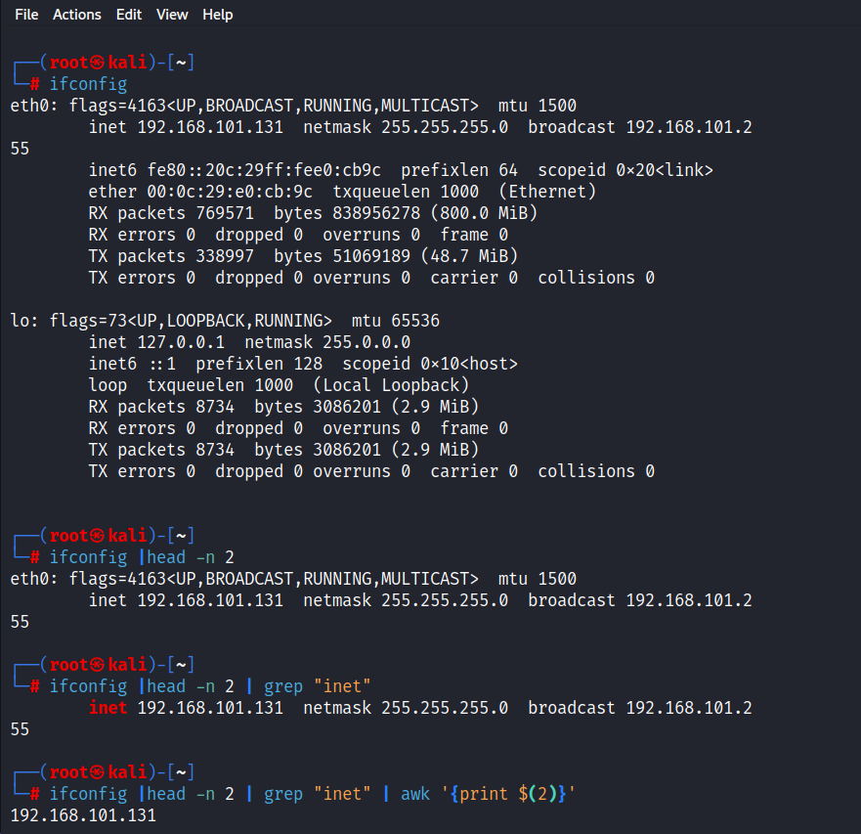

1. curl -s ifconfig.co)

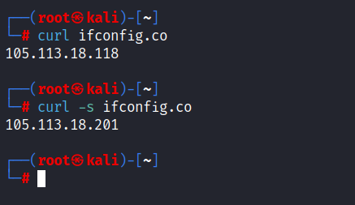

1. ip r | grep "via" | awk '{print $(3)}')

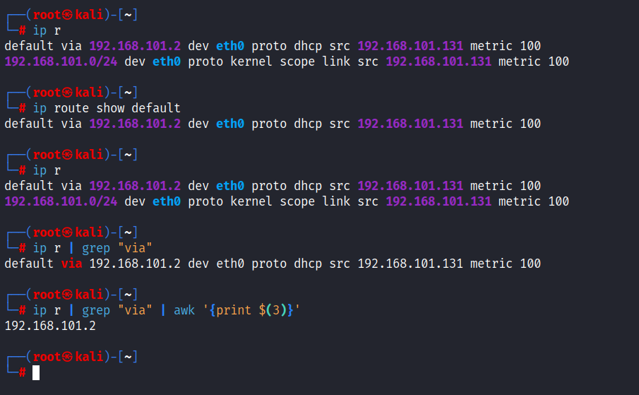

1. **Display the hard disk size; free and used space.**

Command used:

echo -e "Size: $(df -H | grep -e "sd" -e "Filesystem" | awk '{print $2}' | tail -n1) \t Used: $(df -H | grep -e "sd" -e "Filesystem" | awk '{print $3}' | tail -n1) \t Free: $(df -H | grep -e "sd" -e "Filesystem" | awk '{print $4}' | tail -n1)"

**Part 1 - Disk size**

df -H | grep -e "sd" -e "Filesystem" | awk '{print $2}' | tail -n1

**Part 2 - Used**

df -H | grep -e "sd" -e "Filesystem" | awk '{print $3}' | tail -n1

**Part 3 - Free**

(df -H | grep -e "sd" -e "Filesystem" | awk '{print $4}' | tail -n1

Note: All put together with produce this out put

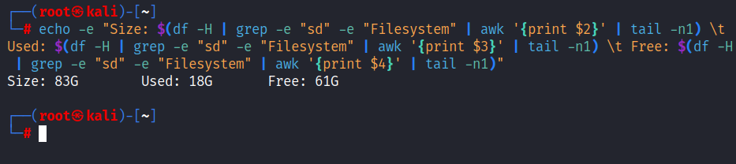

1. **Display the top five (5) directories and their size.**

Command used:

du -sh /* 2>/dev/null | sort -rh | head -n5

**Output:**

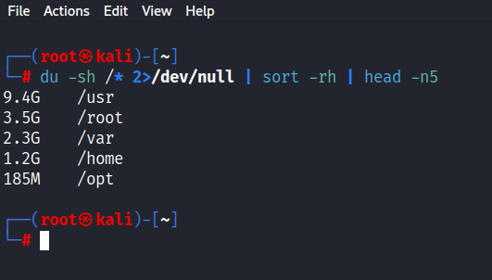

du - Directory usage, -sh --- summarise $ present human readable, 2>/dev/null - don’t output error

And , | sort -rh | head -n5 - to sort in reverse order of hierarchy and highlight top five

1. **Display the CPU usage; refresh every 10 seconds.**

while true

do

echo "CPU usage; Refreshes every 10seconds"

echo "%CPU used: $(top -b -n 5 -d1 | grep "%Cpu(s)" | tail -n 1 | awk '{print $2}' | awk -F. '{print $1}')%"

sleep 10

Done

Note: I did this by wrapping it in a function in my script check my .sh script for this project.

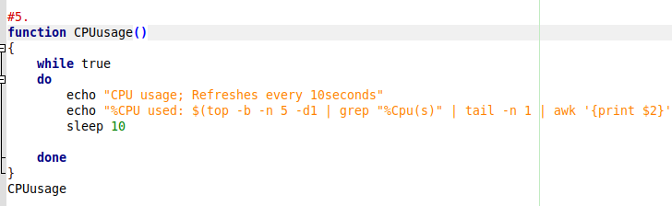

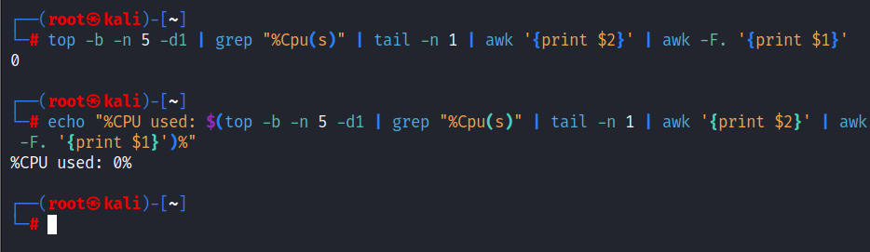

**Screenshot of all the command run in a bash .sh script**

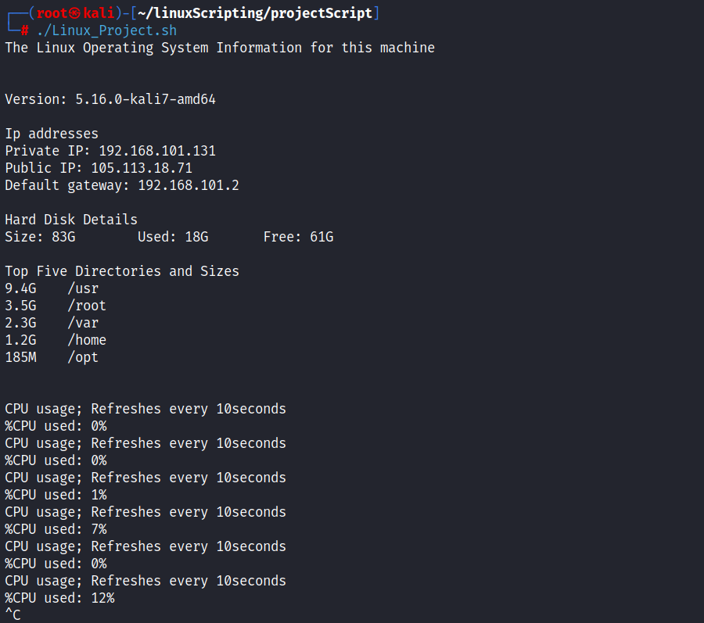

**End**